Quaker South Asia Interest Group

Saturday 1st April 2023
10am to 12.30am
Welcome
Monzurul Islam Chowdhury, Abu Siddique, Penny Robbins, Rob Gallagher, Anne Smith, Martin & Liz Schweiger, Pat Saunders, Stephanie Ramamurthy, John & Sue Smithson, Norman Smith, Stuart Morton, Subhash Kattel, Leon Miller.

Apologies
Jenny Knox, Judith Baker, Gerald Conyngham, Adrian Glamorgan.

Opening period of Worship.

Introductions
All present were invited to introduce themselves.

Monzurul Islam. Executive Director of Gonno Unayan Prochesta
Reported on the activities of GUP. Following the death of Ataur Rahman there were problems in obtaining funds, particularly for the empowerment work and the handicrafts. Microfinance is now actively supported. Around 500 GUP staff. GUP now works in 14 districts and has a Physiotherapy Hospital in Khalia. The Peace Centre is still there but not being used as much as previously. GUP land has been lost in Dhaka (around 100 decimals) when it was taken by the Government of Bangladesh but some new land has been purchased and a new multi-story office will be built. Tin Shed buildings in Rajoir to be replaced because the repair costs are now increasing.
A 5 year strategic plan is being worked on. Helpful discussion with Abu Siddique have been held.
Website is www.gupbd.org The last Annual Report will be uploaded soon.
22nd April 2023 there will be the 50th anniversary of GUP. May be an invitation for others to join.

Dilruba Haider UN Women Gender responsive Climate Change Actions
Prevented from attending today. We will invite her again for our October meeting.

Rob Gallagher
Has recently returned from a month working in Dhaka on a new transport project funded by the Asian Development Bank. This is a larger project than the previous versions, but there has been little in the way of implementation of the previous plans. There are 20 to 30 years worth of reports available to look at. Mobility is getting worse in Dhaka. There are now a lot of motorcycles because they are more mobile than cars. Many high rise buildings going up. A lot of uncertainty about how earthquake resistant they are with a gap between current regulations and what is actually built, apart from legacy buildings. There are now plans for 40 story building. Fire risk also needs more considerations. Space between buildings is very limited making both access and egress difficult. Farm Gate now has an elevated railway (Metro from Uttara to Motijheel) and an elevated expressway for cars built with Japanese money. Air quality is bad during the dry season, sometimes said to be the worst in the world. Dhaka is also now very noisey.
It is the start of Ramzan, fasting is a community activity and a collective experience.
The Taka has lost 25% of its value against the US Dollar and there is marked inflation with the economy in difficulties. There should be an election next year. The Bangladesh Nationalist Party wants a caretaker government in place before the election, the Awami League are opposed to this.
Water supply is becoming a problem, particularly in the dry season. Ground water level is dropping. The infra-structure for water and sewage is not keeping up with the city’s growth.
On a positive note there are many talented and energetic young people who are optimistic about the future.

Leon Miller – Conflict Reduction and Peace Building in South Asia
Leon is based in Estonia but is working on bringing a peaceful approach to conflict in south Asia. Quaker contacts since the 1960s. Most work in India but he is seeking opportunities to work in Afghanistan. Current work is in Assam, Mikalia, Bhubaneshwar and Odisha (Naxalites), Pakistan and Bangladesh. There are armed separatist groups in these areas who are opposing what is seen as development. For tribal groups with a long tradition of living in harmony with the world around them modernisation is seen as threatening, there is a need to explore ways of reconciling the different approaches.
Tribal groups think in terms of ethnic group, distinct from the rest of the population, so they pursue things for their own exclusive interest. They wish to live in accordance with their own values. In some situations their own interest is in harmony with the wider population, one example is knowledge of medicinal plants which they can harvest, process and sell.
Migrants from Bangladesh into Assam and the refugees from Myanmar coming into Bangladesh means there are changes in the nature of the local majority population which can easily lead to violent conflict. Education can contribute to peace building and the alternatives to violence project (AVP) has a lot to offer.
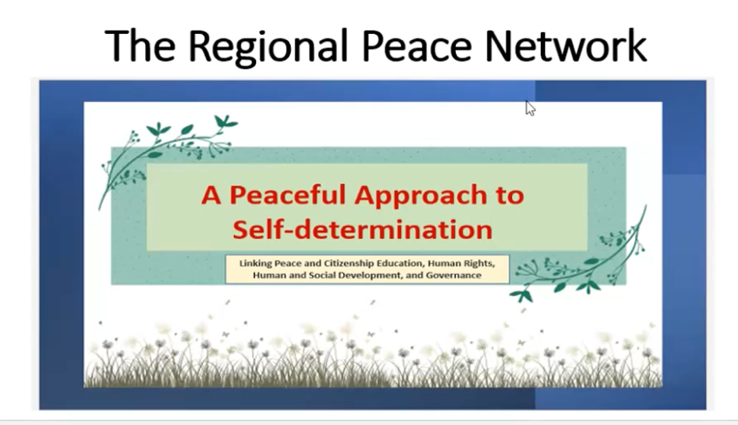
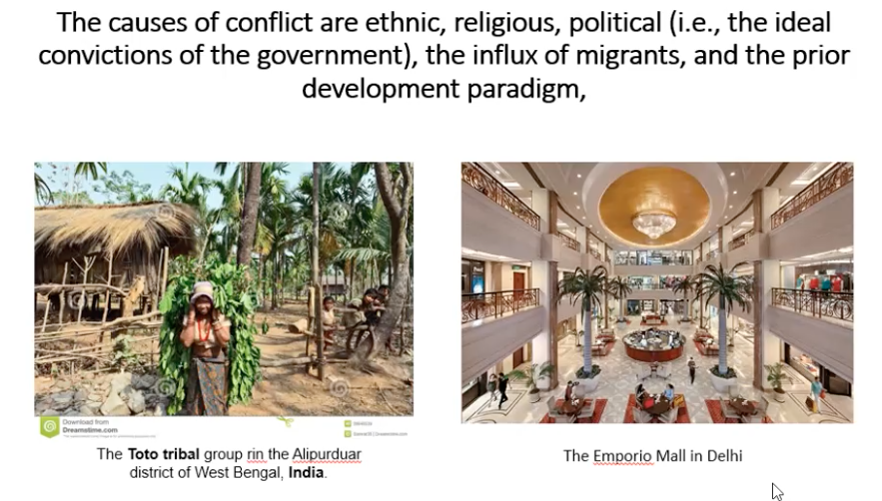
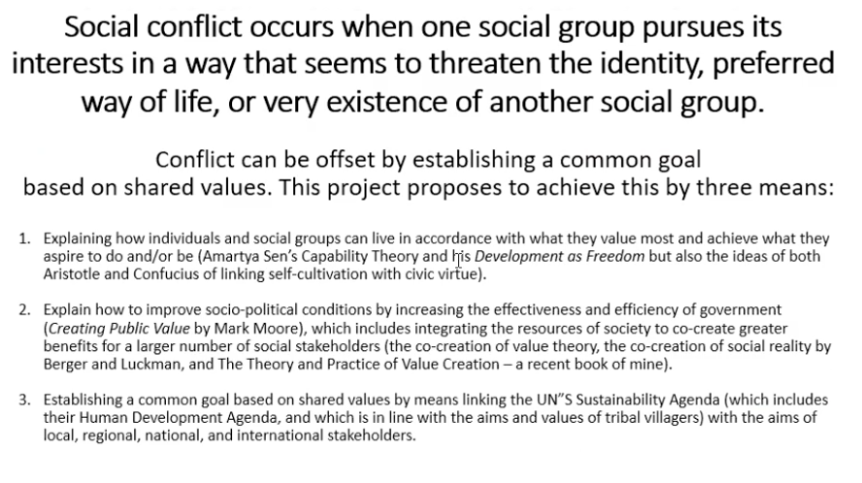
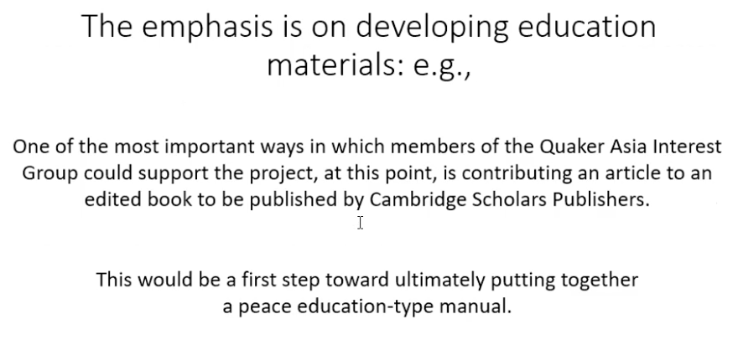

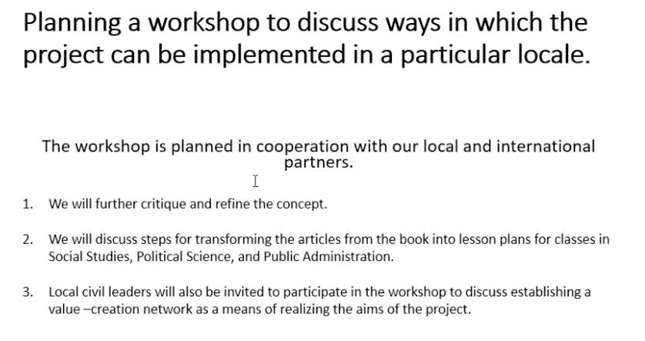
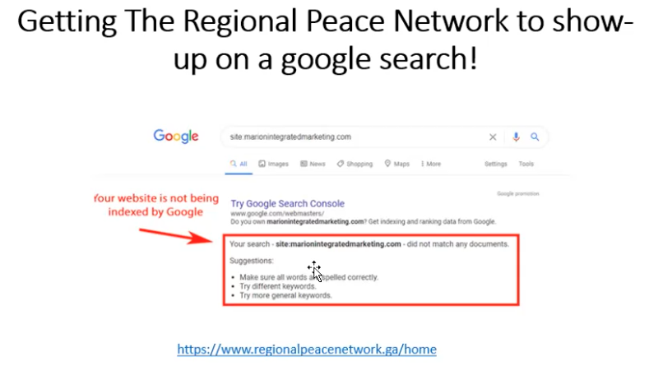

Specific help welcomed with:
- Writing an article. Leon to make a style guide available and make suggesytins about the content.
- Help with holding workshops. Suggestions were made about the possible use of the Peace Centre at GUP’s base in Rajoir, Bangladesh.
- Help with making the website easier to find with Google.
If you want to know more or can help please contact Leon on: leonmonroemiller@yahoo.com

Margaret Waterworth
Reported on a recent visit to Government Schools in West Bengal. There are about 100 residential children in each school. Also visit to Sundarbans where there is a shortage of teachers. May change qualifications for teachers to include time in the villages.

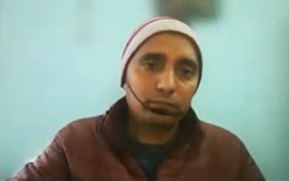
Subhash Kattel
Speaking from Kathmandu, Nepal. Subash talked about the big canvas being used by Leon. There are different approaches to self-determination.
Involvement with the South Asia Peace Alliance (SAPA), 9 countries involved. The internal conflict in Myamnar now generates little media attention but is generating a lot of consequences across the region. This pattern is repeated with other conflicts so need to sustain peace work even when the media has gone.
Developing a network of peace workers in association with SAPA. Also involved with War Resisters International.
Organisations come in with big questions but then leave. War and peace ideas come from the West, over a century of consequences.
How do we make arms production illegal?
How do we bring peace workers together?

Merryl Titus from Bhopal
Sent an email as unable to participate today.

Greetings from Dr. Sanjeev Shukla , Principal Friends Girls School Sohagpur.

In academic session 2022-23 Friends Girls School Sohagpur has taken two initiatives first one is Computer Literacy Programme & other one is Washroom Construction Work.

We all know that this is an era of Information Technology. Childrens & Parents gives more emphasis on Computer Study. Most of the students of Friends Girls School Sohagpur comes from rural areas and they are unable to pay extra money for joining computer classes.

From December 1st ,2022 Friends Girls School Sohagpur started Basic Computer Class under "Computer Literacy Programme" supported by QPSW Simmons Grant ( BYM) for 50 Girls student's who enrolled in 6th to 10th standard in School . Computer classes are conducting regularly & children are learning with exitement in guidance of trained mentor Maya Thakur & Tanu Arse. In May 2023 exams will be conducted for next lable entry. (Photographs with attachment for reference)

As Friends Girls School Sohagpur were founded by early Quakers in 1875 and all the buildings and facilities are too old. So that,to providing better facility of Washroom for children's Friends Girls School Sohagpur has started construction of two blocks of Washroom with modern sanitary fittings in 500 sq ft area. Construction work is completed upto roof level. On Tuesday 28th March 2023 RCC roof work was finished and after 3 weeks interior work will be done. (Photographs of Construction work with attachment for reference)

Please pass on my Greetings to everyone!

In Peace and Love,
Merryl Titus
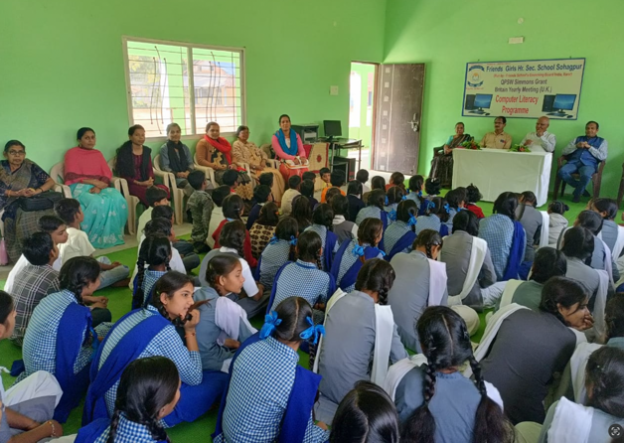
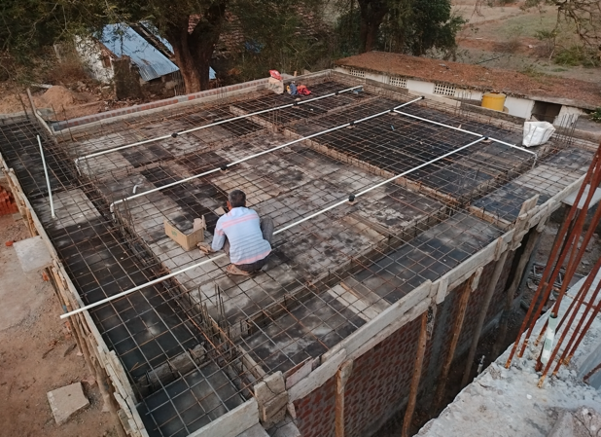
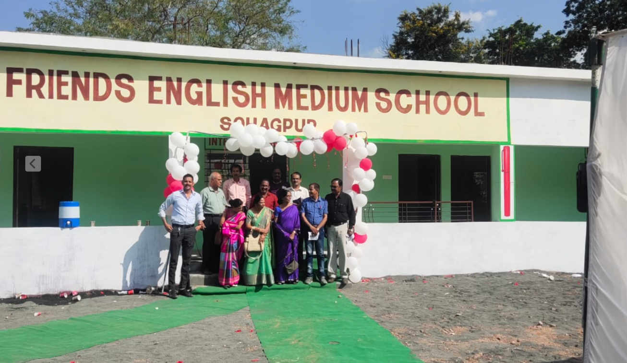

Pat Saunders
Two decades of working on historical maps of Bangladesh, this is coming to a conclusion and we hope that this will soon be published. We hope that the publication will be in Bangladesh. The idea for doing this work came from Ataur Rahman at GUP. Some help also came from Saleem ul Haq, director of the International Centre for Climate Change and Development (ICCCAD) in Bangladesh who has been very active at recent COP sessions.
QSAIG at BYM Groups Fair at 5pm on Saturday 22 April 2023.
We hope you will attend but to do so you must register with Yearly Meeting. If you have not already booked, please go to: https://www.quaker.org.uk/ym

Comments and contributions for the QSAIG Newsletter always welcome, please send to Rob Gallagher as soon as possible.
Comments and contributions for the QSAIG Website always welcome, see: http://www.qsaig.co.uk

Please also note: https://www.youtube.com/watch?v=88xAD0jZAlY This is a film about communities in India resisting mega coal mining.

Thanks to all for participation.

Date of Next Meeting:
Saturday 7th October 2023.
10am to 3.30pm.
Hybrid Meeting to be held on Zoom and at Westminster Meeting House, London.

